**Senses Lesson #2: Exploring our World with Touch**

Jordan G., Rebecca, Lieneke, Brittany, & Kelsey

**NSES Content Standards:**

Science as Inquiry

* Content Standard A:
  + Abilities necessary to do scientific inquiry
  + Understanding about scientific inquiry

Physical Science

* Content Standard B
  + Properties of objects and materials
    - * Objects have many observable properties, including size, weight, shape, color, temperature, and the ability to react with other substances. These properties can be measured using tools such as rulers, balances and thermometers

**NB Curriculum Standards:**

You and Your World, Unit 3: Our Senses

K 3.1 identify the five senses and describe methods to care for them;  
K 3.2 use one or more of their senses to explore the characteristics of materials, noting   
how materials can be manipulated  
K 3.3 develop vocabulary about sensory experiences that permits meaningful communication of ideas.

**Engaging Question:**   
How do we use our sense of touch to explore our world and how can we protect the organs we use to touch?  
  
Materials  
*Exploration:*

* a copy of “Marty’s Morning” Story
* fleece blanket
* stuffed bear
* closed toothpaste tube
* cold bottle of milk
* heat pad
* honey in a cup
* wet wipes
* gravel on a plate
* a smooth, hard rock

*Explanation:*

* Cut out silhouette of a body (Word Wilma) or SMARTboard slide
* Key words (bolded in story) written on cue cards or typed and covered with boxes on SMART Notebook
* Marker
* Chart Paper
* Merlin the Safety Monkey Stuffed Monkey
* Snowsuit, Scarf, winter hat, boots (on Merlin)
* Mittens (For Merlin)

*Expansion:*

* 4 “One does not belong” boxes- pre-assembled (three items should be the same (ie. Hard) and one should be different (ie. Soft)
* Assessment Checklist
* Pen
* Body Outline Worksheet

*Evaluation:*

* Assessment Checklist
* Pen

**Exploration**:

Goal: The teacher reads a story and students pass around objects to understand the concept of touch.

Read the following story aloud and pass around the objects as indicated:

Marty’s Morning

Marty woke up one morning and ran his hands over his **soft** blanket (Fleece blanket). He was so excited for everything he was going to learn today! Mr. Tiddlywinks, his bear, was still lying beside him. When he picked him up he felt his **fuzzy** fur (stuffed bear) and gave him a big bear hug. All of the sudden his mother yelled. “Hurry up and get ready, it is time for school.” Marty squeezed his toothpaste and felt how **squishy** (closed toothpaste tube) the tube was. For breakfast Marty poured **cold** milk (cold bottle of milk) onto his **hot** oatmeal (heat pad). It was delicious!  Then he watched his mother pack him a **sticky** honey sandwich for lunch (honey in a cup and wet wipe). Marty placed his pencil in his book bag and pricked his finger on the **pointy** end (pencil). After his mom gave him a Band-Aid he ran out the door toward the bus. On the way to the bus, Marty noticed the **rough** gravel under his shoes (gravel on a plate). He looked down and saw a **smooth**, **hard** rock (smooth, hard rock) that he decided to add to his rock collection in his bedroom.  It was only 7:30 in the morning and he had already felt so many different textures and temperatures. He loved exploring the world around him. Can you find some things that you can explore using your sense of touch?

**Explanation**

Word Wall

Goal: Add to our unit word wall: Word Wilma (A silhouette giant paper cut out or SMART board slide)

1. Students will point out words we read in the story “Marty’s Morning” that are related to touch and we will stick the corresponding cue cards around the hands of *Word Wilma*.  
   Cue card words include: Touch, Feel, Soft, Hard, Fuzzy, Sticky, Squishy, Smooth, Rough, Cold, Hot, Pointy

Mini Discussion:

1. Ask students: What kinds of things can we touch?
2. Have students give examples of objects that represent a few of the word wall words.

Merlin the Safety Monkey -

Goal: Add to Merlin’s safety gear for each new sense by adding a new item to his.

1. Have students sing the following song to the tune of the *Alice the Camel*:  
   Merlin the monkey has no mitts . Merlin the monkey has no mitts . Merlin the monkey has no mitts, so Merlin’s hands will be cold.

**Expansion**

1. In groups of 4 give students a box of 4 items (three that feel the same and one that is different). Students figure out which one item is not like the others and remove it from the group. Students then raise their hands to show they have figured out which one does not belong. The teacher listens to their reasoning and uses the evaluation checklist to keep track of students who show understanding of the terms and concepts.
2. Hand out a body silhouette sheet to each student and have them draw what they would use to protect their hands if they were going out in the winter.
3. On the blank side of the same sheet have students must pick a word from our Word Wilma Wall and draw one thing that might be described using that word.
4. Closing group discussion:

Teacher will ask students to return to the communal space and poses questions that assess predictions of what a particular object may feel like. (ie. What could a balloon feel like?)

**Evaluation**

*Hands-on*

Students should be able to sort objects with different textures and temperatures. The teacher will record this information on a checklist during the Expansion activity.

*Reflective and Pictorial Assessment*

Hand out Body silhouette sheet to each student and have them draw what they would use to protect their hands if they were going out in the winter. On the blank side of the same sheet have students must pick a word from our Word Wilma Wall and draw one thing that might be described using that word. The teacher will collect drawings and record on check list to assess understanding.

App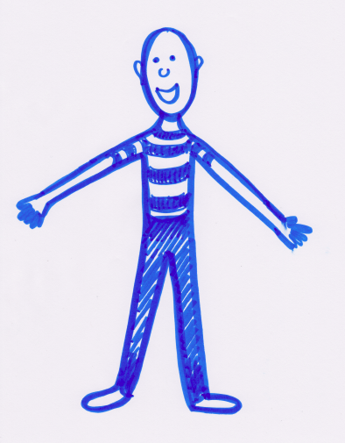

|  |  |  |
| --- | --- | --- |
| Touch | Feel | Soft |
| Hard | Fuzzy | Sticky |
| Squishy | Smooth | Rough |
| Cold | Hot | Pointy |